# BT Master help information

* **Connect to Bluetooth device**

**The red test clip is clamped to the positive side of the battery and the black test clip is clamped to the negative side of the battery.**

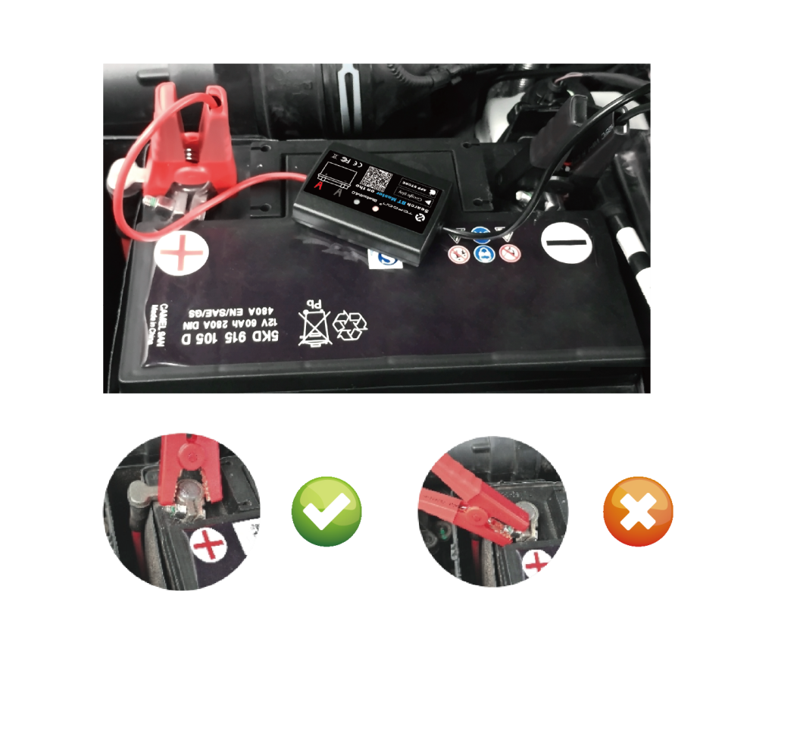

* **Connect app software**

**1.Download app software**

**APP Name：BT Master**

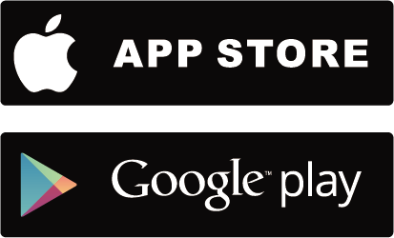

**2．Connect a Bluetooth device**

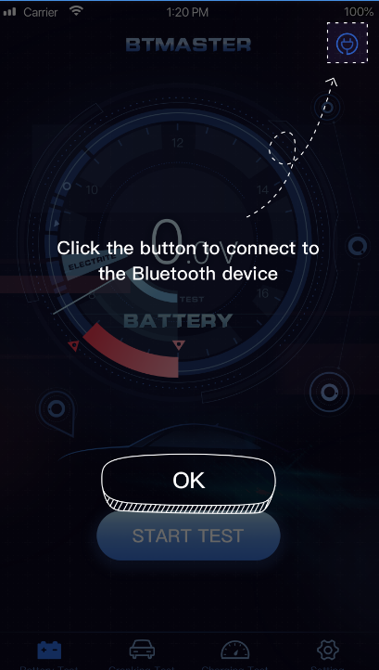 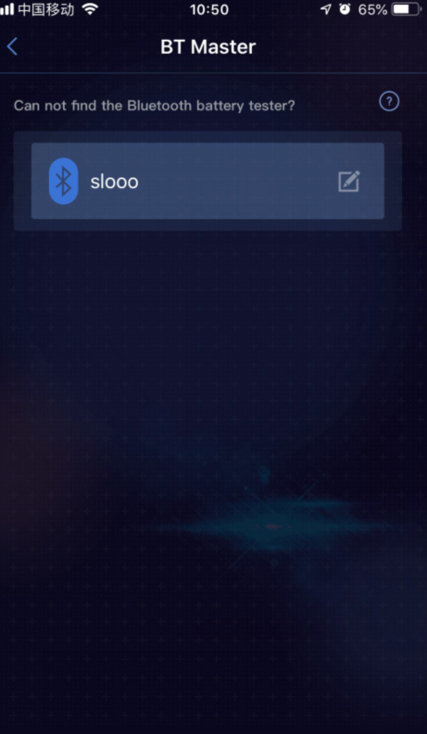

**3.** I**nput battery standard**

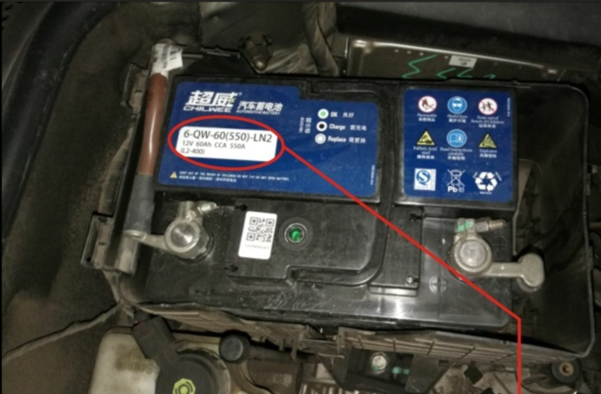

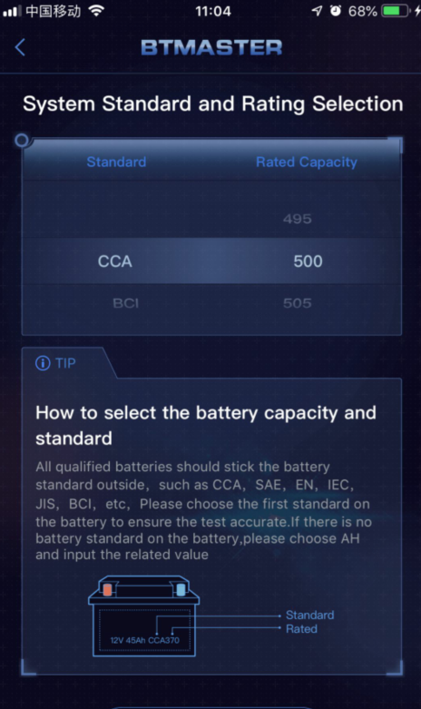

**4.Tested battery system and health status**

**Battery Test**

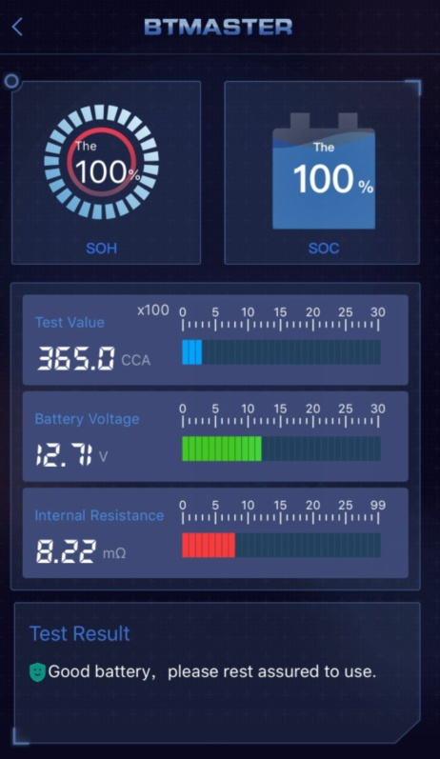

**Cranking Test**

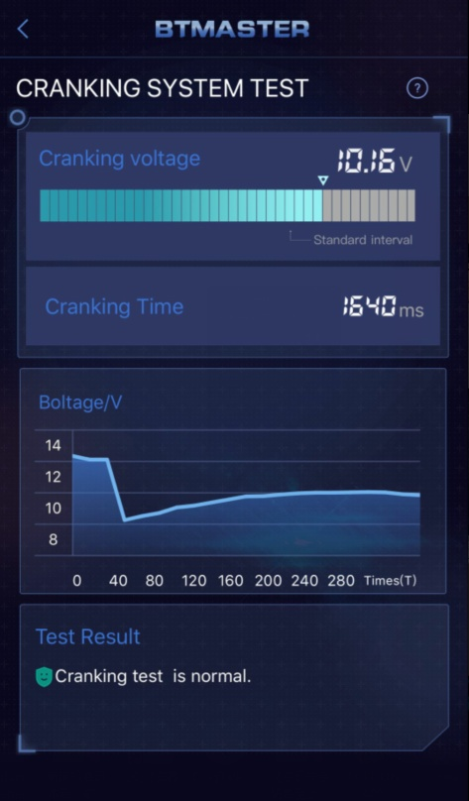

**Charging Test**

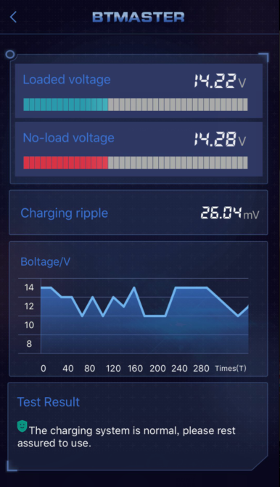

**If you encounter any problems during the operation of the equipment, please send an email to** [**lrm@topdon.com**](mailto:lrm@topdon.com)

# Thank you for your purchase!

**TOPDON Tech Co.,LTD**

**Service Hotline：0755-82596235**

**TOPDON Official website：**[**www.topdon.com**](http://www.topdon.com)

